Weapon Research and conceptualization:

Option 1- Realistic Guns:

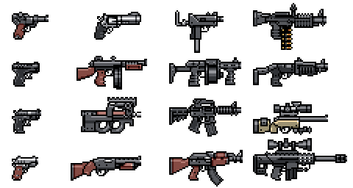

Used in Roguelikes alongside Original weapons. Offer little space for customization, but we can pick from a large list of weapons to adapt to the game.

Option 2 - Original Guns:

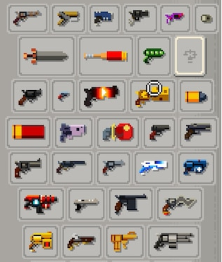

Have more of an “over the top” feel. Can be easily customized and creating the assets for them won’t be as much as a challenge.

Option 3 - Spells:

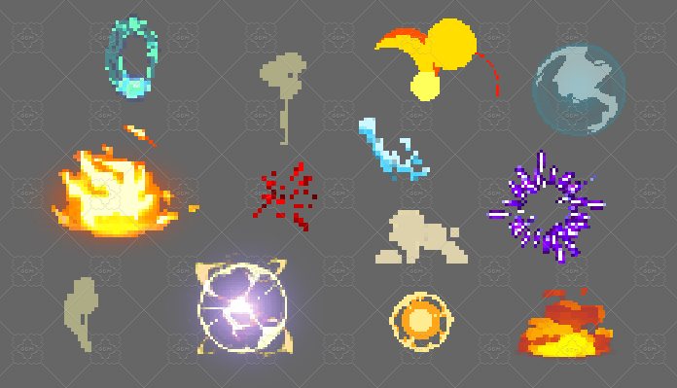

Harder to justify the knockback (core mechanic) for some of them. Assets already available for them. Can be possible to use them with another option (As a stretch goal).

Overall, after analyzing Wizards of Legend, Nuclear Throne, Enter the Gungeon and Risk of Rain, the best overall solution would be to opt with creating ridiculous and over the top guns, as they justify the kickback (core mechanic), asset creation will be easier and they will allow us to experiment with their visuals.